# Ex No: 4 b

# Date:14:8:24 ANALYZE NETWORK TRAFFIC USING WIRESHARK TOOL

**AIM:**

To capture, save, filter and analyze network traffic on TCP / UDP / IP / HTTP / ARP /DHCP /ICMP /DNS using Wireshark Tool

**Exercises**

**1. Capture 100 packets from the Ethernet: IEEE 802.3 LAN Interface and save it.**

# Procedure

⮚ Select Local Area Connection in Wireshark.

⮚ Go to capture  option

⮚ Select stop capture automatically after 100 packets.

⮚ Then click Start capture.⮚ Save the packets.

# Output

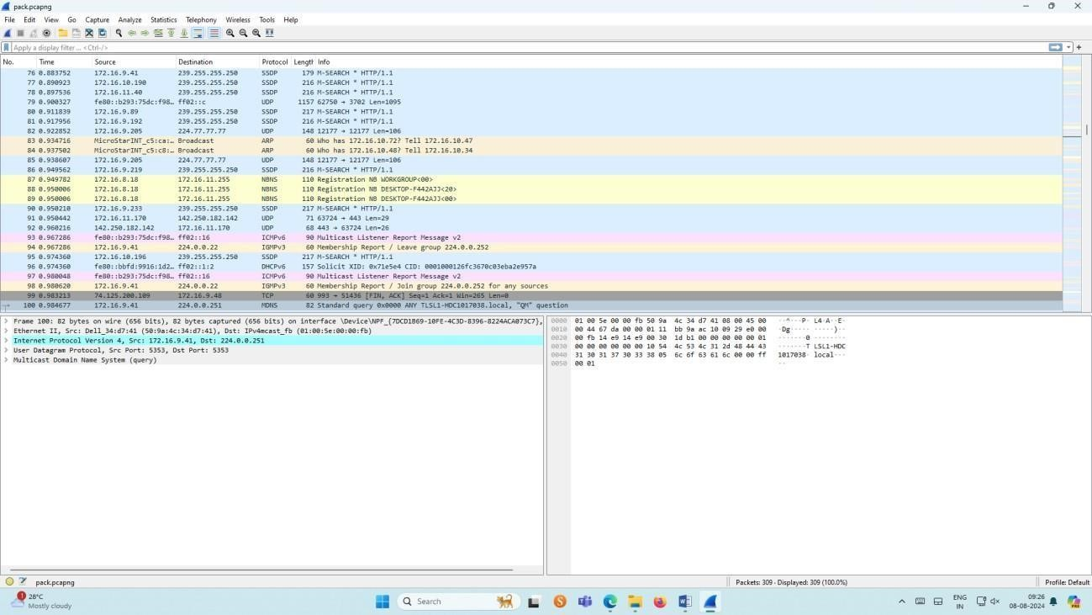

**2.Create a Filter to display only TCP/UDP packets, inspect the packets and provide the flow graph.**

# Procedure

⮚ Select Local Area Connection in Wireshark.

⮚ Go to capture  option

⮚ Select stop capture automatically after 100 packets.

⮚ Then click Start capture.

⮚ Search TCP packets in search bar.

⮚ To see flow graph click StatisticsFlow graph.⮚ Save the packets.

**Output:**

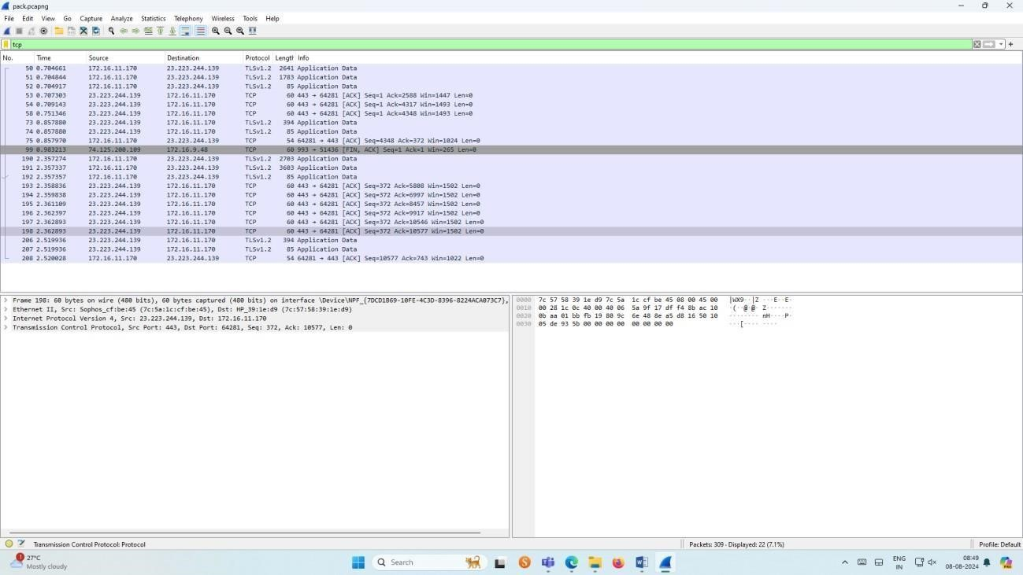

# Flow Graph output

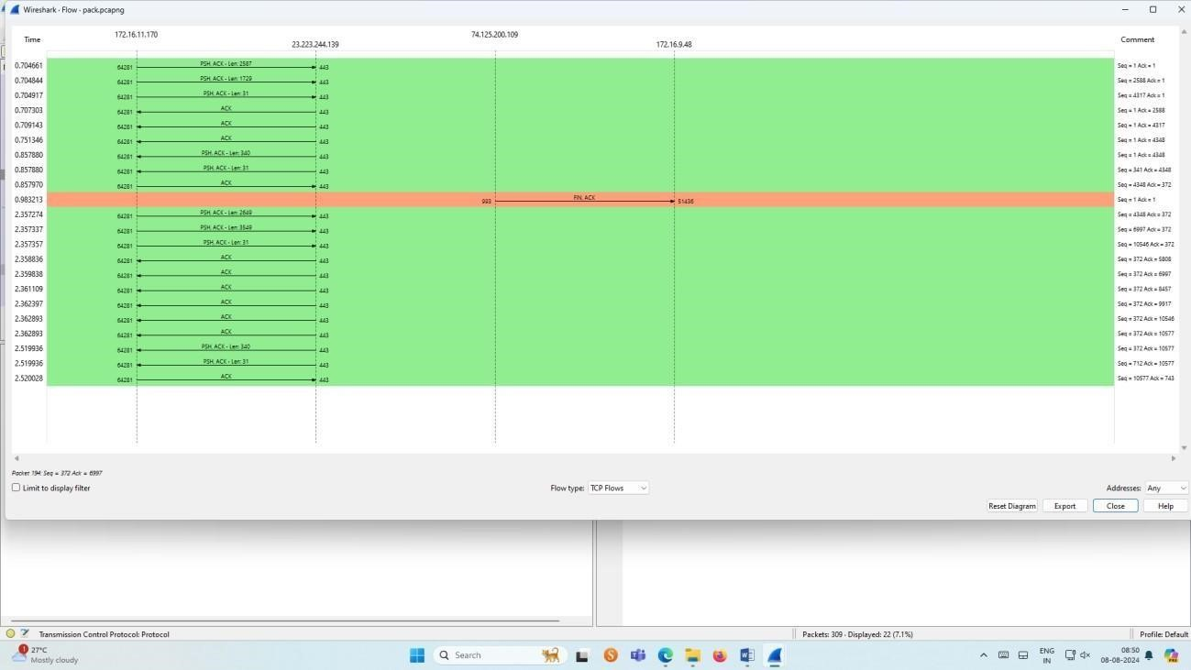

**3.Create a Filter to display only ARP packets and inspect the packets.**

# Procedure

⮚ Select Local Area Connection in Wireshark.

⮚ Go to capture  option

⮚ Select stop capture automatically after 100 packets.

⮚ Then click Start capture.

⮚ Search ARP packets in search bar.

⮚ Save the packets.

# Output

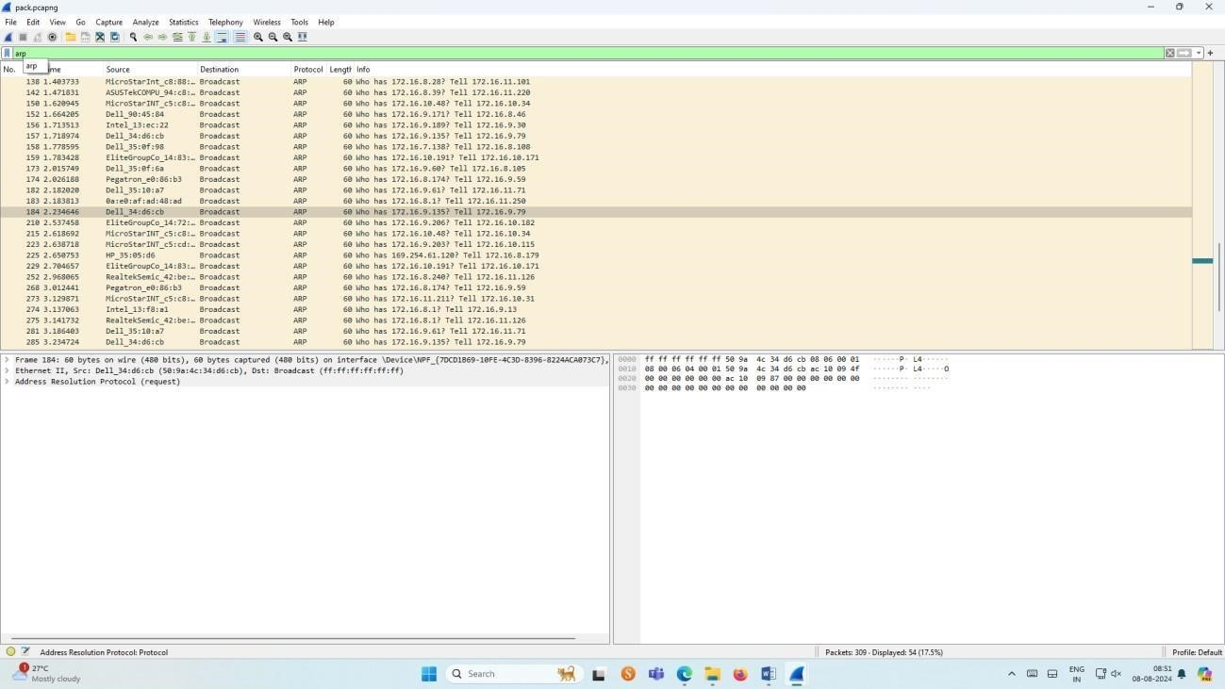

**4.Create a Filter to display only DNS packets and provide the flow graph.**

# Procedure

⮚ Select Local Area Connection in Wireshark.

⮚ Go to capture  option

⮚ Select stop capture automatically after 100 packets.

⮚ Then click Start capture.

⮚ Search DNS packets in search bar.

⮚ To see flow graph click StatisticsFlow graph.

⮚ Save the packets.

# Output

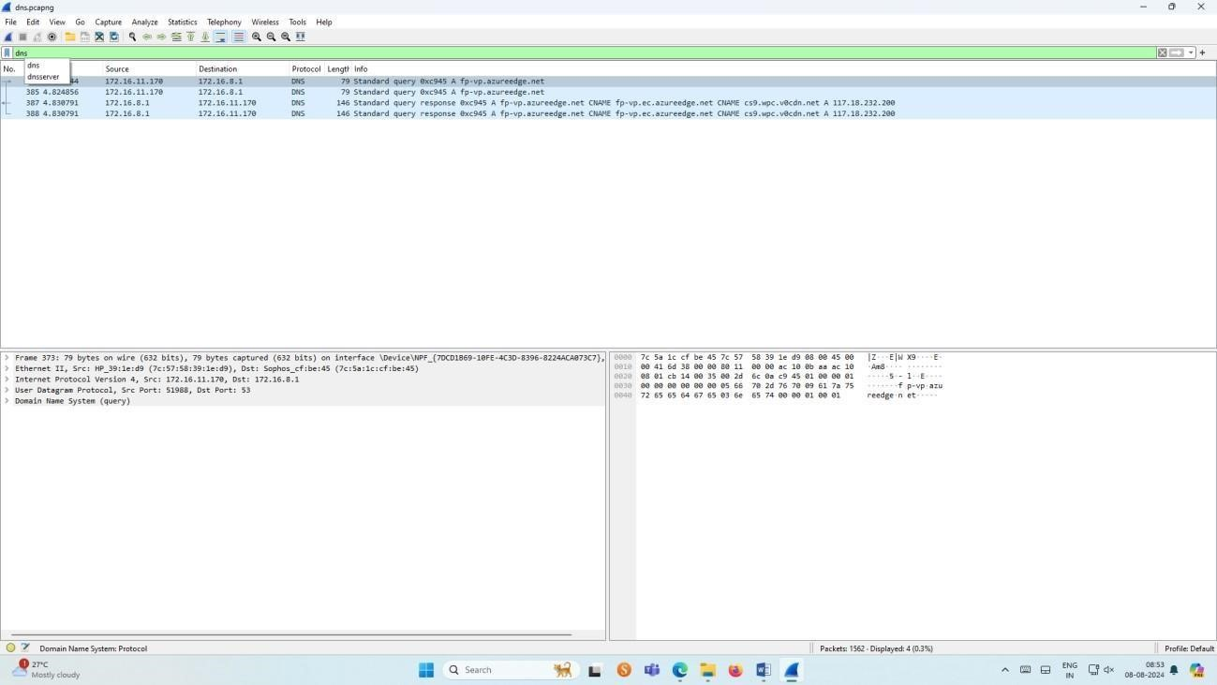

# Graph output

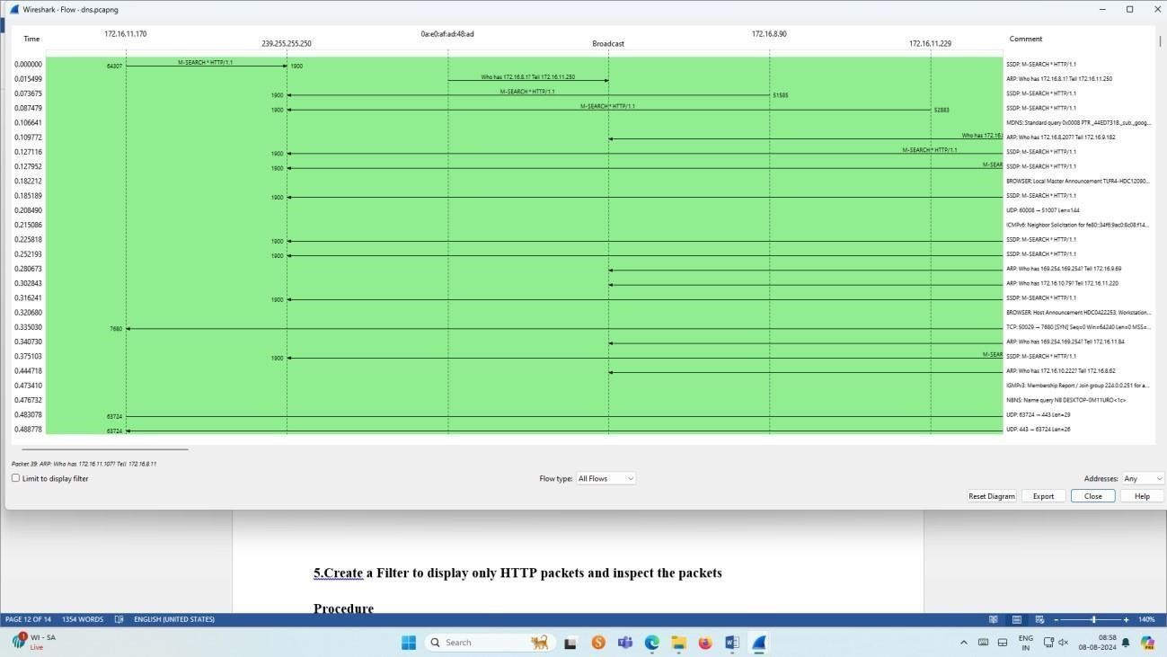

**5.Create a Filter to display only HTTP packets and inspect the packets**

# Procedure

⮚ Select Local Area Connection in Wireshark.

⮚ Go to capture  option

⮚ Select stop capture automatically after 100 packets.

⮚ Then click Start capture.

⮚ Search HTTP packets in the search bar.

⮚ Save the packets.

# Output

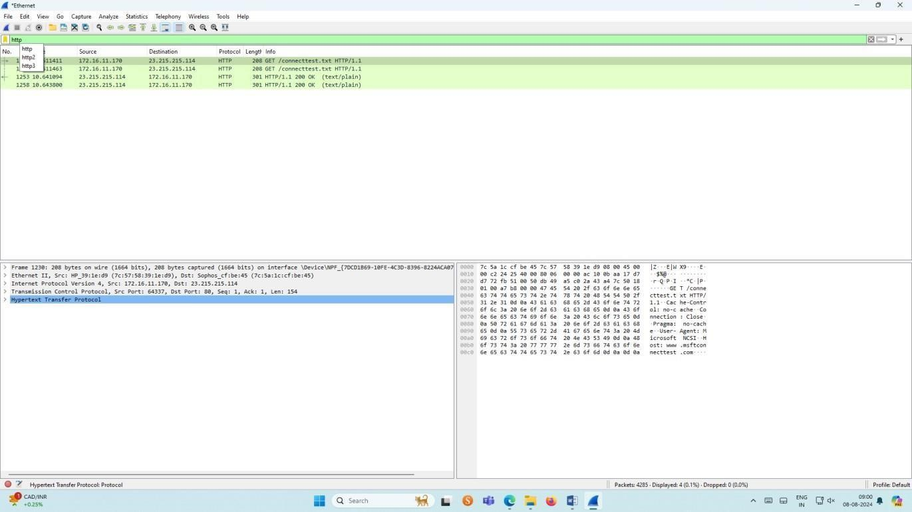

# Flow Graph output

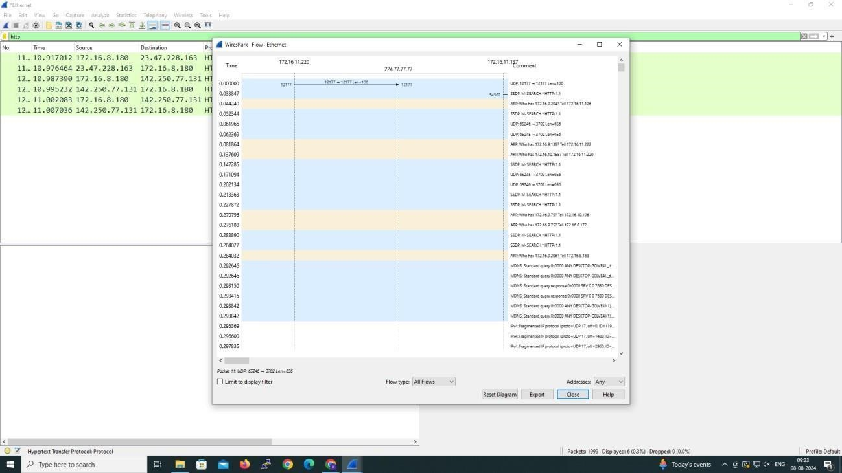

**6.Create a Filter to display only IP/ICMP packets and inspect the packets.**

# Procedure

⮚ Select Local Area Connection in Wireshark.

⮚ Go to capture  option

⮚ Select stop capture automatically after 100 packets.

⮚ Then click Start capture.

⮚ Search ICMP/IP packets in search bar.

⮚ Save the packets

# Output

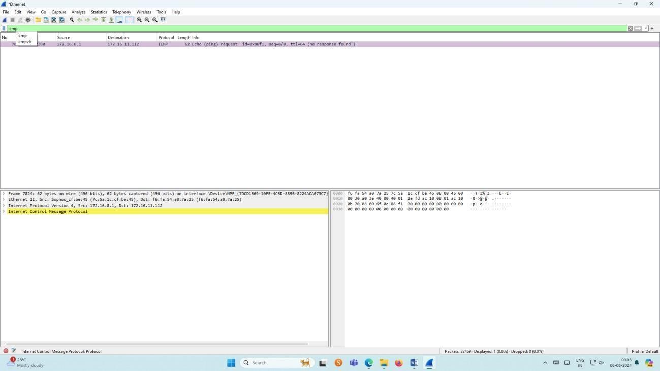

# Flow Graph output

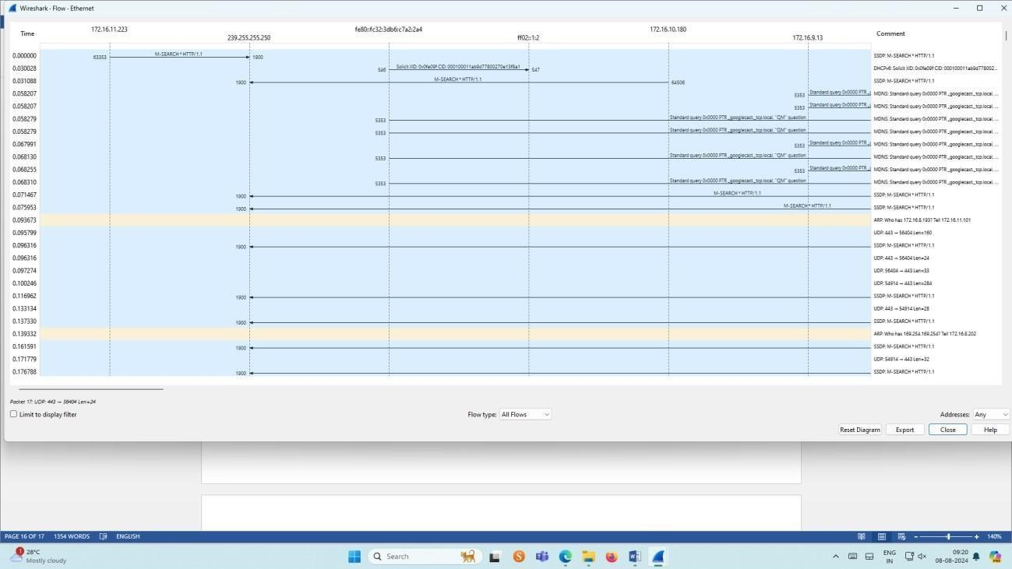

**7.Create a Filter to display only DHCP packets and inspect the packets.**

# Procedure

⮚ Select Local Area Connection in Wireshark.

⮚ Go to capture  option

⮚ Select stop capture automatically after 100 packets.

⮚ Then click Start capture.

⮚ Search DHCP packets in search bar.

⮚ Save the packets

# Output

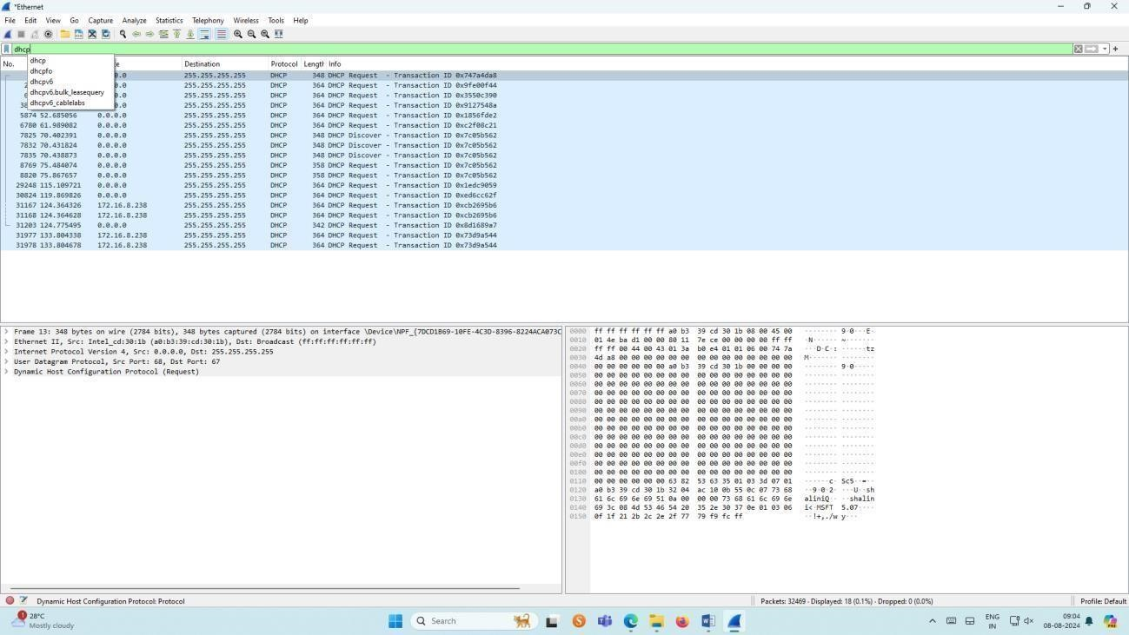

**Result:**

Thus,the study of packet sniffing using wireshark has been verified.